**Automated tests using Selenium with Java for an E-commerce website**

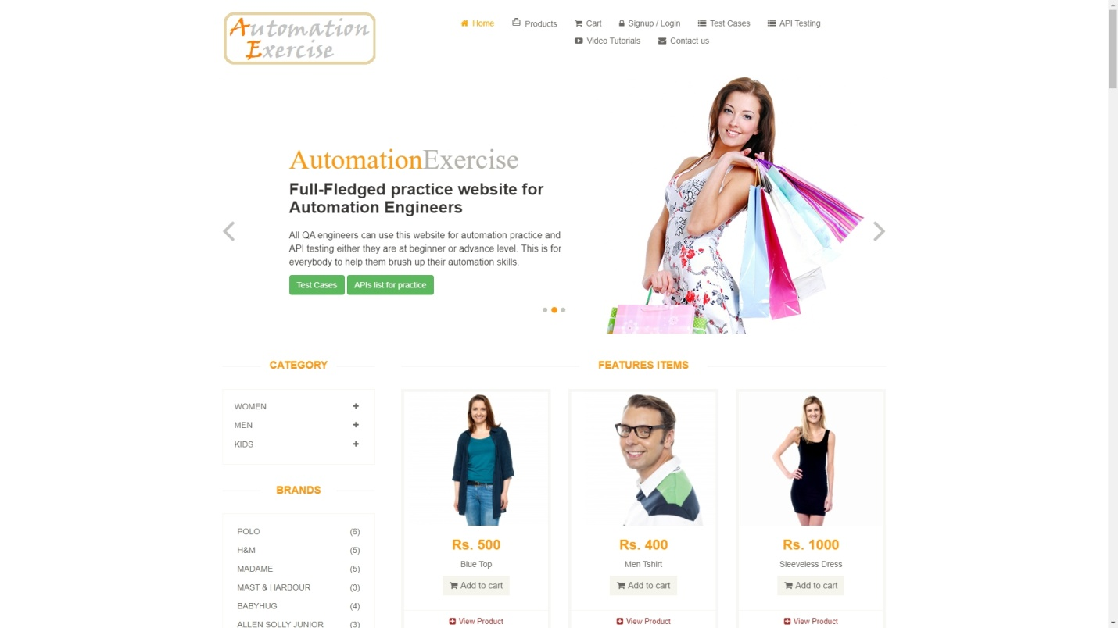

**About this project**

The project was created to practice test automation skills using the Selenium (Java) framework, utilizing skills learned in a course on the Udemy platform. The website under test is a website specifically designed for automated testing. The project contains a total of 26 automated tests, created based on test cases defined by the site's developers. After running and executing the tests, using the proper command, a test report can be generated, which describes in detail the activities performed and the statuses of each test.

**🎨 Project Design:**

* Page Object Model
* Fluent Interface
* Data-Driven approach
* Behavior-Driven approach

## The project includes all available test cases:

### Test Case 1: Register User

1. Launch browser

2. Navigate to url '[http://automationexercise.com](http://automationexercise.com/)'

3. Verify that home page is visible successfully

4. Click on 'Signup / Login' button

5. Verify 'New User Signup!' is visible

6. Enter name and email address

7. Click 'Signup' button

8. Verify that 'ENTER ACCOUNT INFORMATION' is visible

9. Fill details: Title, Name, Email, Password, Date of birth

10. Select checkbox 'Sign up for our newsletter!'

11. Select checkbox 'Receive special offers from our partners!'

12. Fill details: First name, Last name, Company, Address, Address2, Country, State, City, Zipcode, Mobile Number

13. Click 'Create Account button'

14. Verify that 'ACCOUNT CREATED!' is visible

15. Click 'Continue' button

16. Verify that 'Logged in as username' is visible

17. Click 'Delete Account' button

18. Verify that 'ACCOUNT DELETED!' is visible and click 'Continue' button

### Test Case 2: Login User with correct email and password

1. Launch browser

2. Navigate to url '[http://automationexercise.com](http://automationexercise.com/)'

3. Verify that home page is visible successfully

4. Click on 'Signup / Login' button

5. Verify 'Login to your account' is visible

6. Enter correct email address and password

7. Click 'login' button

8. Verify that 'Logged in as username' is visible

### Test Case 3: Login User with incorrect email and password

1. Launch browser

2. Navigate to url '[http://automationexercise.com](http://automationexercise.com/)'

3. Verify that home page is visible successfully

4. Click on 'Signup / Login' button

5. Verify 'Login to your account' is visible

6. Enter incorrect email address and password

7. Click 'login' button

8. Verify error 'Your email or password is incorrect!' is visible

### Test Case 4: Logout User

1. Launch browser

2. Navigate to url '[http://automationexercise.com](http://automationexercise.com/)'

3. Verify that home page is visible successfully

4. Click on 'Signup / Login' button

5. Verify 'Login to your account' is visible

6. Enter correct email address and password

7. Click 'login' button

8. Verify that 'Logged in as username' is visible

9. Click 'Logout' button

10. Verify that user is navigated to login page

### Test Case 5: Register User with existing email

1. Launch browser

2. Navigate to url '[http://automationexercise.com](http://automationexercise.com/)'

3. Verify that home page is visible successfully

4. Click on 'Signup / Login' button

5. Verify 'New User Signup!' is visible

6. Enter name and already registered email address

7. Click 'Signup' button

8. Verify error 'Email Address already exist!' is visible

### Test Case 6: Contact Us Form

1. Launch browser

2. Navigate to url '[http://automationexercise.com](http://automationexercise.com/)'

3. Verify that home page is visible successfully

4. Click on 'Contact Us' button

5. Verify 'GET IN TOUCH' is visible

6. Enter name, email, subject and message

7. Upload file

8. Click 'Submit' button

9. Click OK button

10. Verify success message 'Success! Your details have been submitted successfully.' is visible

11. Click 'Home' button and verify that landed to home page successfully

### Test Case 7: Verify Test Cases Page

1. Launch browser

2. Navigate to url '[http://automationexercise.com](http://automationexercise.com/)'

3. Verify that home page is visible successfully

4. Click on 'Test Cases' button

5. Verify user is navigated to test cases page successfully

### Test Case 8: Verify All Products and product detail page

1. Launch browser

2. Navigate to url '[http://automationexercise.com](http://automationexercise.com/)'

3. Verify that home page is visible successfully

4. Click on 'Products' button

5. Verify user is navigated to ALL PRODUCTS page successfully

6. The products list is visible

7. Click on 'View Product' of first product

8. User is landed to product detail page

9. Verify that detail detail is visible: product name, category, price, availability, condition, brand

### Test Case 9: Search Product

1. Launch browser

2. Navigate to url '[http://automationexercise.com](http://automationexercise.com/)'

3. Verify that home page is visible successfully

4. Click on 'Products' button

5. Verify user is navigated to ALL PRODUCTS page successfully

6. Enter product name in search input and click search button

7. Verify 'SEARCHED PRODUCTS' is visible

8. Verify all the products related to search are visible

### Test Case 10: Verify Subscription in home page

1. Launch browser

2. Navigate to url '[http://automationexercise.com](http://automationexercise.com/)'

3. Verify that home page is visible successfully

4. Scroll down to footer

5. Verify text 'SUBSCRIPTION'

6. Enter email address in input and click arrow button

7. Verify success message 'You have been successfully subscribed!' is visible

### Test Case 11: Verify Subscription in Cart page

1. Launch browser

2. Navigate to url '[http://automationexercise.com](http://automationexercise.com/)'

3. Verify that home page is visible successfully

4. Click 'Cart' button and scroll down to footer

5. Verify text 'SUBSCRIPTION'

6. Enter email address in input and click arrow button

7. Verify success message 'You have been successfully subscribed!' is visible

### Test Case 12: Add Products in Cart

1. Launch browser

2. Navigate to url '[http://automationexercise.com](http://automationexercise.com/)'

3. Verify that home page is visible successfully

4. Click 'Products' button

5. Hover over first product and click 'Add to cart'

6. Click 'Continue Shopping' button

7. Hover over second product and click 'Add to cart'

8. Click 'View Cart' button

9. Verify both products are added to Cart

10. Verify their prices, quantity and total price

### Test Case 13: Verify Product quantity in Cart

1. Launch browser

2. Navigate to url '[http://automationexercise.com](http://automationexercise.com/)'

3. Verify that home page is visible successfully

4. Click 'View Product' for any product on home page

5. Verify product detail is opened

6. Increase quantity to 4

7. Click 'Add to cart' button

8. Click 'View Cart' button

9. Verify that product is displayed in cart page with exact quantity

### Test Case 14: Place Order: Register while Checkout

1. Launch browser

2. Navigate to url '[http://automationexercise.com](http://automationexercise.com/)'

3. Verify that home page is visible successfully

4. Add products to cart

5. Click 'Cart' button

6. Verify that cart page is displayed

7. Click Proceed To Checkout

8. Click 'Register / Login' button

9. Fill all details in Signup and create account

10. Verify 'ACCOUNT CREATED!' and click 'Continue' button

11. Verify ' Logged in as username' at top

12. Click 'Cart' button

13. Click 'Proceed To Checkout' button

14. Verify Address Details and Review Your Order

15. Enter description in comment text area and click 'Place Order'

16. Enter payment details: Name on Card, Card Number, CVC, Expiration date

17. Click 'Pay and Confirm Order' button

18. Verify success message 'Congratulations! Your order has been confirmed!'

19. Click 'Delete Account' button

20. Verify 'ACCOUNT DELETED!' and click 'Continue' button

### Test Case 15: Place Order: Register before Checkout

1. Launch browser

2. Navigate to url '[http://automationexercise.com](http://automationexercise.com/)'

3. Verify that home page is visible successfully

4. Click 'Signup / Login' button

5. Fill all details in Signup and create account

6. Verify 'ACCOUNT CREATED!' and click 'Continue' button

7. Verify ' Logged in as username' at top

8. Add products to cart

9. Click 'Cart' button

10. Verify that cart page is displayed

11. Click Proceed To Checkout

12. Verify Address Details and Review Your Order

13. Enter description in comment text area and click 'Place Order'

14. Enter payment details: Name on Card, Card Number, CVC, Expiration date

15. Click 'Pay and Confirm Order' button

16. Verify success message 'Congratulations! Your order has been confirmed!'

17. Click 'Delete Account' button

18. Verify that 'ACCOUNT DELETED!' and click 'Continue' button

### Test Case 16: Place Order: Login before Checkout

1. Launch browser

2. Navigate to url '[http://automationexercise.com](http://automationexercise.com/)'

3. Verify that home page is visible successfully

4. Click 'Signup / Login' button

5. Fill email, password and click 'Login' button

6. Verify 'Logged in as username' at top

7. Add products to cart

8. Click 'Cart' button

9. Verify that cart page is displayed

10. Click Proceed To Checkout

11. Verify Address Details and Review Your Order

12. Enter description in comment text area and click 'Place Order'

13. Enter payment details: Name on Card, Card Number, CVC, Expiration date

14. Click 'Pay and Confirm Order' button

15. Verify success message 'Congratulations! Your order has been confirmed!'

### Test Case 17: Remove Products From Cart

1. Launch browser

2. Navigate to url '[http://automationexercise.com](http://automationexercise.com/)'

3. Verify that home page is visible successfully

4. Add products to cart

5. Click 'Cart' button

6. Verify that cart page is displayed

7. Click 'X' button corresponding to particular product

8. Verify that product is removed from the cart

### Test Case 18: View Category Products

1. Launch browser

2. Navigate to url '[http://automationexercise.com](http://automationexercise.com/)'

3. Verify that categories are visible on left side bar

4. Click on 'Women' category

5. Click on any category link under 'Women' category, for example: Dress

6. Verify that category page is displayed and confirm text 'WOMEN - DRESS PRODUCTS'

7. On left side bar, click on any sub-category link of 'Men' category

8. Verify that user is navigated to that category page

### Test Case 19: View & Cart Brand Products

1. Launch browser

2. Navigate to url '[http://automationexercise.com](http://automationexercise.com/)'

3. Click on 'Products' button

4. Verify that Brands are visible on left side bar

5. Click on any brand name

6. Verify that user is navigated to brand page and brand products are displayed

7. On left side bar, click on any other brand link

8. Verify that user is navigated to that brand page and can see products

### Test Case 20: Search Products and Verify Cart After Login

1. Launch browser

2. Navigate to url '[http://automationexercise.com](http://automationexercise.com/)'

3. Click on 'Products' button

4. Verify user is navigated to ALL PRODUCTS page successfully

5. Enter product name in search input and click search button

6. Verify 'SEARCHED PRODUCTS' is visible

7. Verify all the products related to search are visible

8. Add those products to cart

9. Click 'Cart' button and verify that products are visible in cart

10. Click 'Signup / Login' button and submit login details

11. Again, go to Cart page

12. Verify that those products are visible in cart after login as well

13. Remove all products that have been added

14. Verify 'Cart is empty! Click here to buy products.' is visible

### Test Case 21: Add review on product

1. Launch browser

2. Navigate to url '[http://automationexercise.com](http://automationexercise.com/)'

3. Click on 'Products' button

4. Verify user is navigated to ALL PRODUCTS page successfully

5. Click on 'View Product' button

6. Verify 'Write Your Review' is visible

7. Enter name, email and review

8. Click 'Submit' button

9. Verify success message 'Thank you for your review.'

### Test Case 22: Add to cart from Recommended items

1. Launch browser

2. Navigate to url '[http://automationexercise.com](http://automationexercise.com/)'

3. Scroll to bottom of page

4. Verify 'RECOMMENDED ITEMS' are visible

5. Click on 'Add To Cart' on Recommended product

6. Click on 'View Cart' button

7. Verify that product is displayed in cart page

### Test Case 23: Verify address details in checkout page

1. Launch browser

2. Navigate to url '[http://automationexercise.com](http://automationexercise.com/)'

3. Verify that home page is visible successfully

4. Click 'Signup / Login' button

5. Fill all details in Signup and create account

6. Verify 'ACCOUNT CREATED!' and click 'Continue' button

7. Verify ' Logged in as username' at top

8. Add products to cart

9. Click 'Cart' button

10. Verify that cart page is displayed

11. Click Proceed To Checkout

12. Verify that the delivery address and the billing address is same address filled at the time registration of account

13. Click 'Delete Account' button

14. Verify 'ACCOUNT DELETED!' and click 'Continue' button

### Test Case 24: Download Invoice after purchase order

1. Launch browser

2. Navigate to url '[http://automationexercise.com](http://automationexercise.com/)'

3. Verify that home page is visible successfull

4. Add products to cart

5. Click 'Cart' button

6. Verify that cart page is displayed

7. Click Proceed To Checkout

8. Click 'Register / Login' button

9. Fill all details in Signup and create account

10. Verify 'ACCOUNT CREATED!' and click 'Continue' button

11. Verify ' Logged in as username' at top

12. Click 'Cart' button

13. Click 'Proceed To Checkout' button

14. Verify Address Details and Review Your Order

15. Enter description in comment text area and click 'Place Order'

16. Enter payment details: Name on Card, Card Number, CVC, Expiration date

17. Click 'Pay and Confirm Order' button

18. Verify success message 'Congratulations! Your order has been confirmed!'

19. Click 'Download Invoice' button and verify invoice is downloaded successfully

20. Click 'Continue' button

21. Click 'Delete Account' button

22. Verify 'ACCOUNT DELETED!' and click 'Continue' button

### Test Case 25: Verify Scroll Up using 'Arrow' button and Scroll Down functionality

1. Launch browser

2. Navigate to url '[http://automationexercise.com](http://automationexercise.com/)'

3. Verify that home page is visible successfully

4. Scroll down page to bottom

5. Verify 'SUBSCRIPTION' is visible

6. Click on arrow at bottom right side to move upward

7. Verify that page is scrolled up and 'Full-Fledged practice website for Automation Engineers' text is visible on screen

### Test Case 26: Verify Scroll Up without 'Arrow' button and Scroll Down functionality

1. Launch browser

2. Navigate to url '[http://automationexercise.com](http://automationexercise.com/)'

3. Verify that home page is visible successfully

4. Scroll down page to bottom

5. Verify 'SUBSCRIPTION' is visible

6. Scroll up page to top

7. Verify that page is scrolled up and 'Full-Fledged practice website for Automation Engineers' text is visible on screen